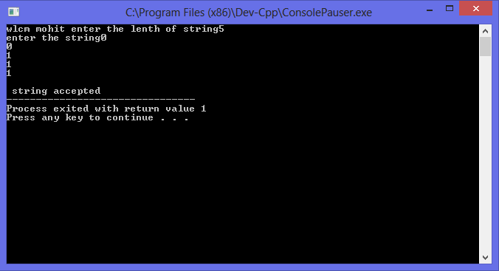

***Expermint No***.___

Q__ -> Wap in c to take a string by user and accept a string in (0^*1^*) format by a dfa ?

***Source Code*** -->

#include<stdio.h>

#include<conio.h>

int main()

{

int a[50],y=1,x=1,i,l,p,m;

printf("wlcm mohit enter the lenth of string");

scanf("%d",&l);

printf("enter the string");

for(i=0;i<l;i++)

scanf("%d",&a[i]);

if(l==0)

printf(" \n string is empty \n \n string accepted");

else

{

for(i=0;i<l;i++)

{if(a[i]==1)

{

p=i;

break;

}

}

for(i=0;i<l;i++)

{

if(a[i]==0)

{

m=i;

break;

}

}

for(i=0;i<m;i++)

{

if(a[i]==1)

x=x+1;

}

for(i=p;i<l;i++)

{

if(a[i]==0)

y=y+1;

}

if(x==1&&y==1)

printf("\n string accepted");

else

printf("string not accepted");

}

return 1;

}